Chapter 1 Question 19 Michael Streyle

##   
## Call:  
## lm(formula = GPA ~ ACT)  
##   
## Coefficients:  
## (Intercept) ACT   
## 2.11405 0.03883

## Analysis of Variance Table  
##   
## Response: GPA  
## Df Sum Sq Mean Sq F value Pr(>F)   
## ACT 1 3.588 3.5878 9.2402 0.002917 **  
## Residuals 118 45.818 0.3883   
## ---  
## Signif. codes: 0 '***' 0.001 '**' 0.01 '*' 0.05 '.' 0.1 ' ' 1

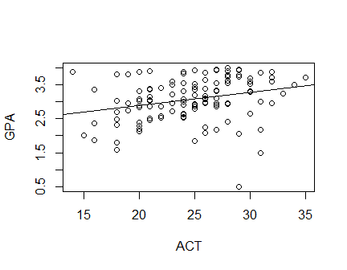

## (Intercept)   
## 3.278863

## (Intercept)   
## 3.31769

The intercept is 2.11 GPA units and the slope is 0.0388 GPA unit per ACT score increment.

Answers Written Out

19)

a) The least squares estimate of β0 and β1 are 2.114049 and 0.03882713 respectively, so the estimated regression function is Ŷ = 2.114049 + 0.03882713(Xi)

b) The best fit line fits the data pretty well, considering the distribution of the data points.

c) For a student with an ACT score of 30, the point estimate of the mean freshman GPA is 3.278863.

d) When the entry ACT score increases to 31, the point estimate of the mean freshman GPA is 3.31769. This means that the mean freshman GPA changes by 0.038827.